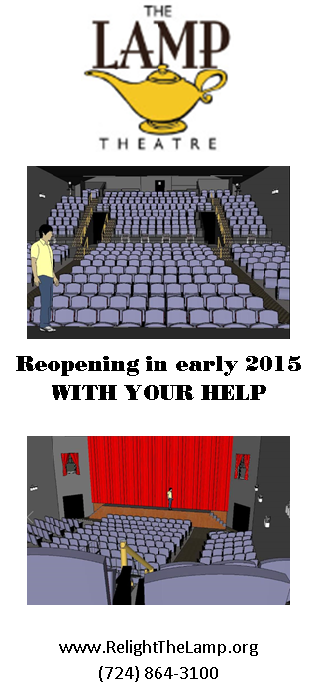
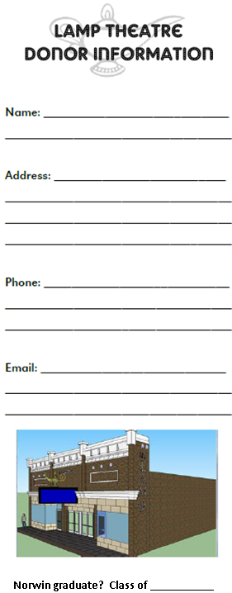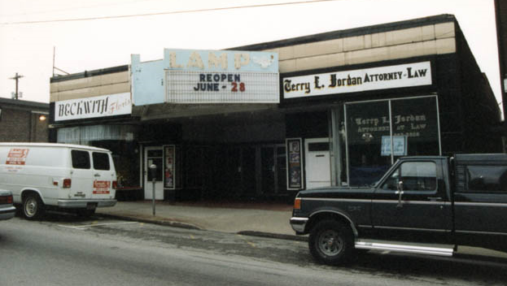
June 1995 photo courtesy of the John Lewis collection & cinematour.com
The Lamp Theatre opened in 1927.
It will now be reopening for the enjoyment of a new generation.
The Grand Opening will be held just in time for the start of a new season of events that are making Downtown Irwin THE cultural place to be. The Lamp will provide an additional venue to help make Irwin’s 2015 events even bigger and better!
Benefits of “Relighting the Lamp”:
- Economic Development
- Live Performances
- Movies & Film Festivals
- Stand-Up Comedy
- Special Guest Appearances, Forums and Meet & Greets
- Ideal for Meetings, Functions, Events and Private Parties
- Beautifully Landscaped Courtyard Café
- Enhance Night Life
- Support Local Performers
- Compliment to Local Businesses
The Lamp Theatre will be a magnet for movie and cultural enthusiasts, drawing them and their entertainment dollars to the Irwin area. This represents a 1 MILLION dollar economic impact for our area!
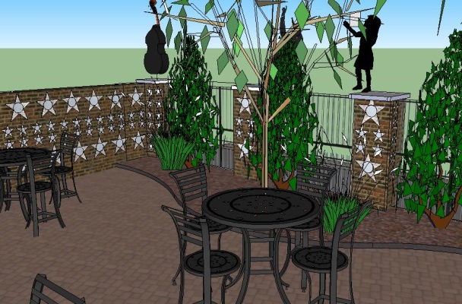

We still need volunteers! Contact Dee - dmeighan@duncangrp.com - for info
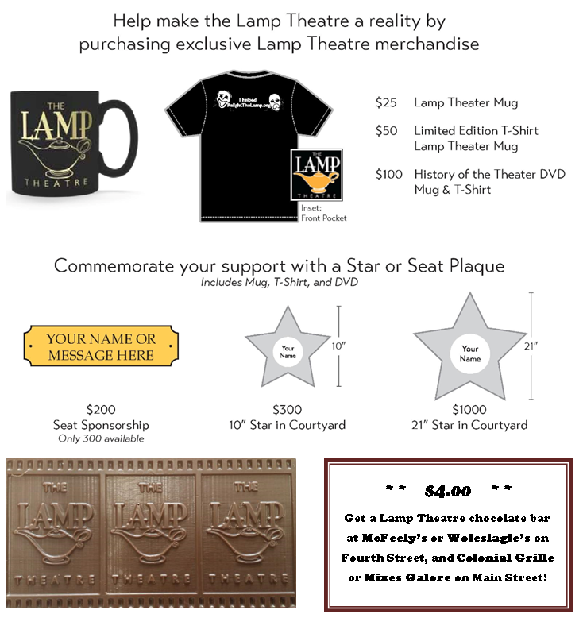
Stage Pass .
Donations of $2,000 and up will receive a 21” Courtyard Star, choice of box seat license when available (in order of gift amount), and two tickets to opening night plus two passes to the exclusive “after party”.
Courtyard Stars .
21” - $1,000 Total: $___________
10” - $300 Total: $___________
Engraving:___________________________________________________________________________
Seat Sponsors .
$200 Total: $___________
Engraving: (Limit 2 lines, 25 characters per line)
____________________________________________________________________________________
Donations .
$100 $50 $25

TOTAL DONATIONS: $_____________
Thank you!
Checks payable to: The Irwin Project
Detach form & return along with donation to:
The Lamp Theatre
424 Main Street, Irwin, PA 15642
Questions? Call (724) 864-3100
The Irwin Project is a 501(c)(3) non-profit organization

